DNA Fingerprinting Worksheet
I. RESTRICTION DIGEST

1. What does the restriction enzyme do to the DNA?

2. Why are the DNA samples put into the incubator?

3. Predict what will happen to the DNA you prepared in part I while it is in the incubator.

II. PREPARATION OF THE AGAROSE GEL

1. What is the function of the Agarose gel?

2. Predict what would happen if you used 0.02 g of Agarose instead of 0.2 g. What effect would that have on the experiment?

3. What is the function of the comb?

III. PREPARATION OF THE GEL ELECTROPHORESIS BOX

1. Predict what would happen if you put the wells of the agarose gel at the positive pole.

2. Why is the gel in electrophoresis buffer?

3. Describe what is occurring in the gel when the electric current is applied.

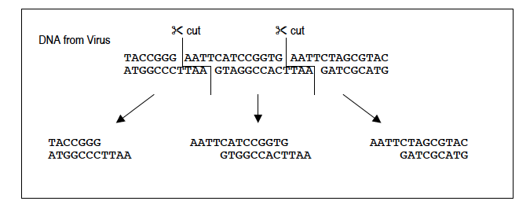
A natural enemy of bacteria is a virus. To defend them when attacked by a virus, bacteria use chemical weapons that breakup the DNA of the virus. The action of these chemicals on the viral DNA is shown in the diagram below:

Use the diagram above to complete the sentences or answer the questions below:
1. The chemical that cuts the DNA is called a restriction enzyme. Restriction enzymes cut the
DNA into _________________.
.
2. The restriction enzyme used above is called EcoRI. EcoRI cuts DNA everywhere the base
pattern_____________________is found.

3. Another restriction enzyme is HaeIII. It cuts DNA at the base sequence CCGG. It cuts
between the C and G. Show the DNA fragments that would result if HaeIII was used to cut the
DNA fragment shown in the diagram above.

4. Do you think restriction enzymes could be used to cut DNA from other organisms?

5. The words BOB and MADAM are called palindromes. What are palindromes? (hint: spell the
words backwards)

6. What do palindromes have to do with the way restriction enzymes cut DNA?

7. You are using a restriction enzyme that cuts at the CCGG. Cut between the C and G. It does not leave sticky ends. Show where it would cut on this DNA strand. Count the number of base pairs in each band. Using a chart like the one below the DNA strands mark draw the bands for each of the strands of DNA shown.

Crime Scene
GTCGACCGGTGACCGTGCGTACACAGTGCTCCGGATAGCTGATAGCTCCGGTG
CAGCTGGCCACTGGCACGCATGTGTCACGAGGCCTATCGACTATCGAGGCCAC

Suspect 1
GTCCCAGCCGGACCGTACCGGTAGATCAGCCGGTAGATTGATAGCGTGATGTG
CAGGGTCGGCCTGGCATGGCCATCTAGTCGGCCATCTAACTATCGCACTACAC

Suspect 2
GTCTACGTAATCGTAGCCATCCGGACAGTGTGCACGATCGTACATGCTACGTG
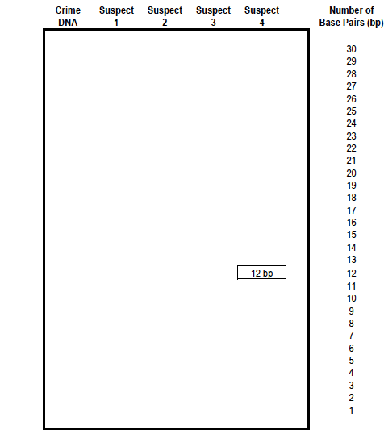
CAGATGCATTAGCATCGGTAGGCCTGTCACACGTGCTAGCATGTACGATGCAC

